**Windows 和消息**

**消息和消息队列**

| **名称** | **说明** |
| --- | --- |
| [消息和消息队列](https://learn.microsoft.com/zh-cn/windows/win32/winmsg/messages-and-message-queues) | 本部分介绍消息和消息队列，以及如何在应用程序中使用它们。 |
| [关于消息和消息队列](https://learn.microsoft.com/zh-cn/windows/win32/winmsg/about-messages-and-message-queues) | 本部分讨论 Windows 消息和消息队列。 |
| [使用消息和消息队列](https://learn.microsoft.com/zh-cn/windows/win32/winmsg/using-messages-and-message-queues) | 以下代码示例演示如何执行与 Windows 消息和消息队列关联的以下任务。 |
| [消息引用](https://learn.microsoft.com/zh-cn/windows/win32/winmsg/message-and-message-queue-reference) | 包含 API 引用。 |

**Windows消息类型**

根据消息的来源进行分类，可以分为：

* [系统定义的消息](https://learn.microsoft.com/zh-cn/windows/win32/winmsg/about-messages-and-message-queues#system-defined-messages)
* [应用程序定义的消息](https://learn.microsoft.com/zh-cn/windows/win32/winmsg/about-messages-and-message-queues#application-defined-messages)

根据消息的路由方式分类，可以分为：

* [队列消息](https://learn.microsoft.com/zh-cn/windows/win32/winmsg/about-messages-and-message-queues#queued-messages)
* [非队列消息](https://learn.microsoft.com/zh-cn/windows/win32/winmsg/about-messages-and-message-queues#nonqueued-messages)

**Windows系统的整个消息系统分为3个层级**

1. Windows内核的**系统消息队列**

Windows内核维护着一个全局的系统消息队列；按照线程的不同，系统消息队列中的消息会分发到应用程序的UI线程的消息队列中；

1. 应用程序**UI线程消息队列**

应用程序的每一个UI线程都有自己的消息循环，会不停地从自己的消息队列取出消息，并发送给Windows窗体对象(WinForm控件)；

1. 每个控件自己的**消息处理函数**

WinForm 中的 void WndProc(ref Message m) 消息处理函数

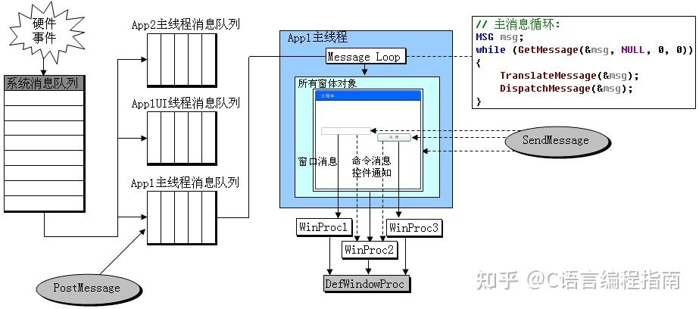

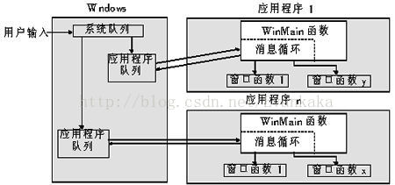

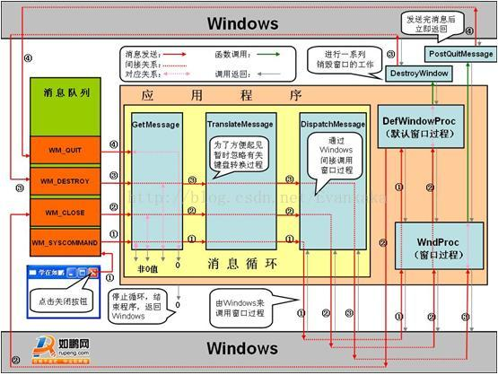

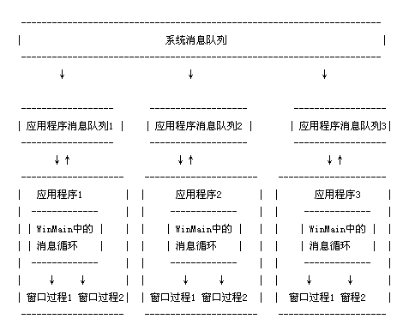

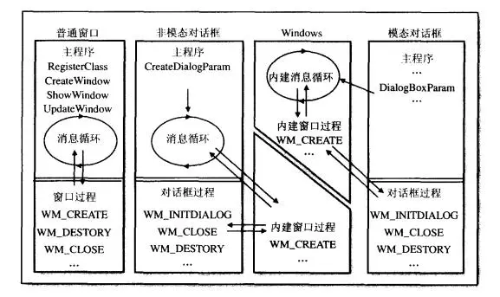

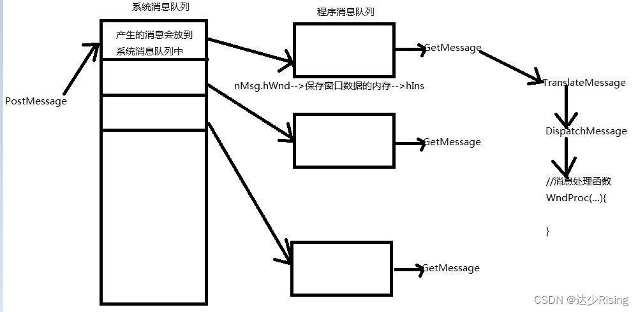

**Q&A**

1. **进程消息队列(应用程序消息队列)和主线程的消息队列是一回事吗？**

在 WinForm 程序中，进程消息队列指的是主线程的消息队列。WinForm 应用程序是单线程的，所有的 UI 操作都必须在主线程中执行。当用户与应用程序的界面交互时，操作系统会将相关的消息发送到应用程序的消息队列中，然后主线程从消息队列中逐个获取并处理这些消息，以更新界面状态和响应用户操作。因此，进程消息队列实际上就是主线程的消息队列。

1. **线程中消息队列消息的结构是怎样的?**

|  |  |
| --- | --- |
|  | **typedef** **struct** **tagMSG** { |
|  | *// 接收消息的窗口的句柄。 当消息是线程消息时，此成员为 NULL 。* |
|  | HWND hwnd; |
|  | *// 消息的标识符。 应用程序只能使用低字;高字由系统保留。* |
|  | UINT message; |
|  | *// 消息的附加信息。 确切含义取决于 消息 成员的值。* |
|  | WPARAM wParam; |
|  | *// 消息的附加信息。 确切含义取决于 消息 成员的值。* |
|  | LPARAM lParam; |
|  | *// 消息的发布时间。* |
|  | DWORD time; |
|  | *// 发布消息时的光标位置（以屏幕坐标表示）。* |
|  | POINT pt; |
|  | *//* |
|  | DWORD lPrivate; |
|  | } MSG, *PMSG, *NPMSG, *LPMSG; |

[msg 结构 (winuser.h)](https://learn.microsoft.com/zh-cn/windows/win32/api/winuser/ns-winuser-msg?redirectedfrom=MSDN)

1. **在WinForm程序中线程Id和托管线程Id是一回事吗？**

线程Id和托管线程Id是不一样的！

可以通过以下方法获取线程的Id

|  |  |
| --- | --- |
|  | */// <summary>* |
|  | */// 获取操作系统线程ID，Windows 10下的偏移量为0x022C(x64-bit-Application)和0x0160(x32-bit-Application)：* |
|  | */// https://www.ibckf.com/questions/1679243* |
|  | */// </summary>* |
|  | */// <param name="thread"></param>* |
|  | */// <returns></returns>* |
|  | public **static** **int** **GetNativeThreadId**(Thread thread) |
|  | { |
|  | var f = typeof(Thread).GetField("DONT_USE_InternalThread", |
|  | BindingFlags.GetField | BindingFlags.NonPublic | BindingFlags.Instance); |
|  |  |
|  | var pInternalThread = (IntPtr)f.GetValue(thread); |
|  | var nativeId = Marshal.ReadInt32(pInternalThread, (IntPtr.Size == 8) ? 0x022C : 0x0160); *// found by analyzing the memory* |
|  | **return** nativeId; |
|  | } |

获取当前线程的托管线程Id

|  |  |
| --- | --- |
|  | public **static** string CurrentThreadId |
|  | { |
|  | get |
|  | { |
|  | var thread = Thread.CurrentThread; |
|  | var threadId = GetNativeThreadId(thread); |
|  | **return** $"{thread.ManagedThreadId} - ({threadId}, 0x{threadId.ToString("x2")})"; |
|  | } |
|  | } |

1. **知道控件的句柄如何获取该控件所在的进程和线程信息？**

|  |  |
| --- | --- |
|  | public **static** **class** **Extensions** |
|  | { |
|  | *// 导入 Windows API 函数* |
|  |  |
|  | */// <summary>* |
|  | */// 检索创建指定窗口的线程的标识符，以及创建该窗口的进程（可选）的标识符。* |
|  | */// GetWindowThreadProcessId 函数 : https://learn.microsoft.com/zh-cn/windows/win32/api/winuser/nf-winuser-getwindowthreadprocessid* |
|  | */// </summary>* |
|  | */// <param name="hWnd">控件句柄</param>* |
|  | */// <param name="processId">控件所属进程Id</param>* |
|  | */// <returns>控件所属线程Id</returns>* |
|  | [DllImport("user32.dll")] |
|  | private **static** **extern** **int** **GetWindowThreadProcessId**(IntPtr hWnd, out **int** processId); |
|  |  |
|  | public **static** **void** **ConsoleHandleInfo**(this Control ctrl, string name) |
|  | { |
|  | var handle = ctrl.Handle; |
|  | var threadId = GetWindowThreadProcessId(handle, out **int** processId); |
|  | Console.WriteLine($"{ThreadInfo.CurrentThreadId} -> 创建 {name} 的进程Id = {processId}，线程Id = {threadId}"); |
|  | } |
|  | } |

**WinForm程序中消息处理的相关方法**

按调用顺序依次介绍，可以对消息进行拦截与处理

1. **IMessageFilter的消息处理**

[IMessageFilter 接口](https://learn.microsoft.com/zh-cn/dotnet/api/system.windows.forms.imessagefilter?view=windowsdesktop-7.0)

一般处理逻辑，在构造函数中调用Application.AddMessageFilter(this);添加消息筛选器，在析构函数中调用Application.RemoveMessageFilter(this);移除消息筛选器，然后重写PreProcessMessage消息处理函数。

**返回值：**如果消息已处理，则为 true；否则为 false。

**影响级别：**应用程序级

1. **Control.PreProcessMessage**

在调度键盘或输入消息之前，在消息循环内对它们进行预处理（**键盘消息预处理函数**）。

**返回值：**如果消息已由控件处理，则为 true；否则为 false。

**影响级别：**应用程序级

重写 [PreProcessMessage](https://learn.microsoft.com/zh-cn/dotnet/api/system.windows.forms.control.preprocessmessage?view=windowsdesktop-7.0)时，控件返回 true 以指示它已处理消息。 对于控件未处理的消息，应返回 base.PreProcessMessage 的结果 。 控件通常会替代更专用的方法之一，例如 [IsInputChar](https://learn.microsoft.com/zh-cn/dotnet/api/system.windows.forms.control.isinputchar?view=windowsdesktop-7.0)、 [IsInputKey](https://learn.microsoft.com/zh-cn/dotnet/api/system.windows.forms.control.isinputkey?view=windowsdesktop-7.0)、 [ProcessCmdKey](https://learn.microsoft.com/zh-cn/dotnet/api/system.windows.forms.control.processcmdkey?view=windowsdesktop-7.0)、 [ProcessDialogChar](https://learn.microsoft.com/zh-cn/dotnet/api/system.windows.forms.control.processdialogchar?view=windowsdesktop-7.0)或 [ProcessDialogKey](https://learn.microsoft.com/zh-cn/dotnet/api/system.windows.forms.control.processdialogkey?view=windowsdesktop-7.0) ，而不是重写 [PreProcessMessage](https://learn.microsoft.com/zh-cn/dotnet/api/system.windows.forms.control.preprocessmessage?view=windowsdesktop-7.0)。

[Control.PreProcessMessage(Message) 方法](https://learn.microsoft.com/zh-cn/dotnet/api/system.windows.forms.control.preprocessmessage?view=windowsdesktop-7.0)

1. **键盘消息的其他处理函数，如 protected override bool IsInputKey(Keys keyData)**
2. **控件的消息处理函数**

|  |  |
| --- | --- |
|  | protected override **void** **WndProc**(ref Message m) |
|  | { |
|  | *// 控件内消息处理函数* |
|  | *//Console.WriteLine($"WndProc-> {m}");* |
|  | base.WndProc(ref m); |
|  | } |

**其他代码片段**

[bool PreProcessMessage(ref Message msg)实现](https://source.dot.net/#System.Windows.Forms/System/Windows/Forms/Control.cs,9075)

|  |  |
| --- | --- |
|  | */// <summary>* |
|  | */// This method is called by the application's message loop to pre-process input messages before they* |
|  | */// are dispatched. If this method processes the message it must return true, in which case the message* |
|  | */// loop will not dispatch the message.* |
|  | */// </summary>* |
|  | */// <remarks>* |
|  | */// <para>* |
|  | */// The messages that this method handles are WM_KEYDOWN, WM_SYSKEYDOWN, WM_CHAR, and WM_SYSCHAR.* |
|  | */// </para>* |
|  | */// <para>* |
|  | */// For WM_KEYDOWN and WM_SYSKEYDOWN messages, this first calls <see cref="ProcessCmdKey(ref Message, Keys)"/>* |
|  | */// to check for command keys such as accelerators and menu shortcuts. If it doesn't process the message, then* |
|  | */// <see cref="IsInputKey(Keys)"/> is called to check whether the key message represents an input key for the* |
|  | */// control. Finally, if <see cref="IsInputKey(Keys)"/> indicates that the control isn't interested in the key* |
|  | */// message, then <see cref="ProcessDialogKey(Keys)"/> is called to check for dialog keys such as TAB, arrow* |
|  | */// keys, and mnemonics.* |
|  | */// </para>* |
|  | */// <para>* |
|  | */// For WM_CHAR messages, <see cref="IsInputChar(char)"/> is first called to check whether the character* |
|  | */// message represents an input character for the control. If <see cref="IsInputChar(char)"/> indicates that* |
|  | */// the control isn't interested in the character message, then <see cref="ProcessDialogChar(char)"/> is* |
|  | */// called to check for dialog characters such as mnemonics.* |
|  | */// </para>* |
|  | */// <para>* |
|  | */// For WM_SYSCHAR messages, this calls <see cref="ProcessDialogChar(char)"/> to check for dialog characters* |
|  | */// such as mnemonics.* |
|  | */// </para>* |
|  | */// <para>* |
|  | */// When overriding this method, a control should return true to indicate that it has processed the message.* |
|  | */// For messages that aren't processed by the control, the result of "base.PreProcessMessage()" should be* |
|  | */// returned.* |
|  | */// </para>* |
|  | */// <para>* |
|  | */// Controls will typically override one of the more specialized methods (<see cref="IsInputChar(char)"/>,* |
|  | */// <see cref="IsInputKey(Keys)"/>, <see cref="ProcessCmdKey(ref Message, Keys)"/>, <see cref="ProcessDialogChar(char)"/>,* |
|  | */// or <see cref="ProcessDialogKey(Keys)"/>) instead of overriding this method.* |
|  | */// </para>* |
|  | */// </remarks>* |
|  | public virtual **bool** **PreProcessMessage**(ref Message msg) |
|  | { |
|  | **bool** result; |
|  |  |
|  | **if** (msg.MsgInternal == PInvoke.WM_KEYDOWN || msg.MsgInternal == PInvoke.WM_SYSKEYDOWN) |
|  | { |
|  | **if** (!GetExtendedState(ExtendedStates.UiCues)) |
|  | { |
|  | ProcessUICues(ref msg); |
|  | } |
|  |  |
|  | Keys keyData = (Keys)(nint)msg.WParamInternal | ModifierKeys; |
|  | **if** (ProcessCmdKey(ref msg, keyData)) |
|  | { |
|  | result = true; |
|  | } |
|  | **else** **if** (IsInputKey(keyData)) |
|  | { |
|  | SetExtendedState(ExtendedStates.InputKey, true); |
|  | result = false; |
|  | } |
|  | **else** |
|  | { |
|  | result = ProcessDialogKey(keyData); |
|  | } |
|  | } |
|  | **else** **if** (msg.MsgInternal == PInvoke.WM_CHAR || msg.MsgInternal == PInvoke.WM_SYSCHAR) |
|  | { |
|  | **if** (msg.MsgInternal == PInvoke.WM_CHAR && IsInputChar((**char**)(nint)msg.WParamInternal)) |
|  | { |
|  | SetExtendedState(ExtendedStates.InputChar, true); |
|  | result = false; |
|  | } |
|  | **else** |
|  | { |
|  | result = ProcessDialogChar((**char**)(nint)msg.WParamInternal); |
|  | } |
|  | } |
|  | **else** |
|  | { |
|  | result = false; |
|  | } |
|  |  |
|  | **return** result; |
|  | } |

**相关参考**

1. [msg 结构 (winuser.h)](https://learn.microsoft.com/zh-cn/windows/win32/api/winuser/ns-winuser-msg?redirectedfrom=MSDN)
2. [Message 结构](https://learn.microsoft.com/zh-cn/dotnet/api/system.windows.forms.message?view=windowsdesktop-7.0)
3. [关于消息和消息队列](https://learn.microsoft.com/zh-cn/windows/win32/winmsg/about-messages-and-message-queues)
4. [使用消息和消息队列](https://learn.microsoft.com/zh-cn/windows/win32/winmsg/using-messages-and-message-queues)
5. [Windows消息机制（MFC深度详解）](https://zhuanlan.zhihu.com/p/643665652)
6. [windows消息机制深入详解](https://blog.csdn.net/u011555996/article/details/122020740)
7. [WINDOWS消息](https://blog.csdn.net/weixin_42284219/article/details/130043242)，消息的解析可以参考此篇
8. [线程与消息队列](https://www.cnblogs.com/yewsky/articles/1882730.html)，介绍线程间相互通信相关的函数